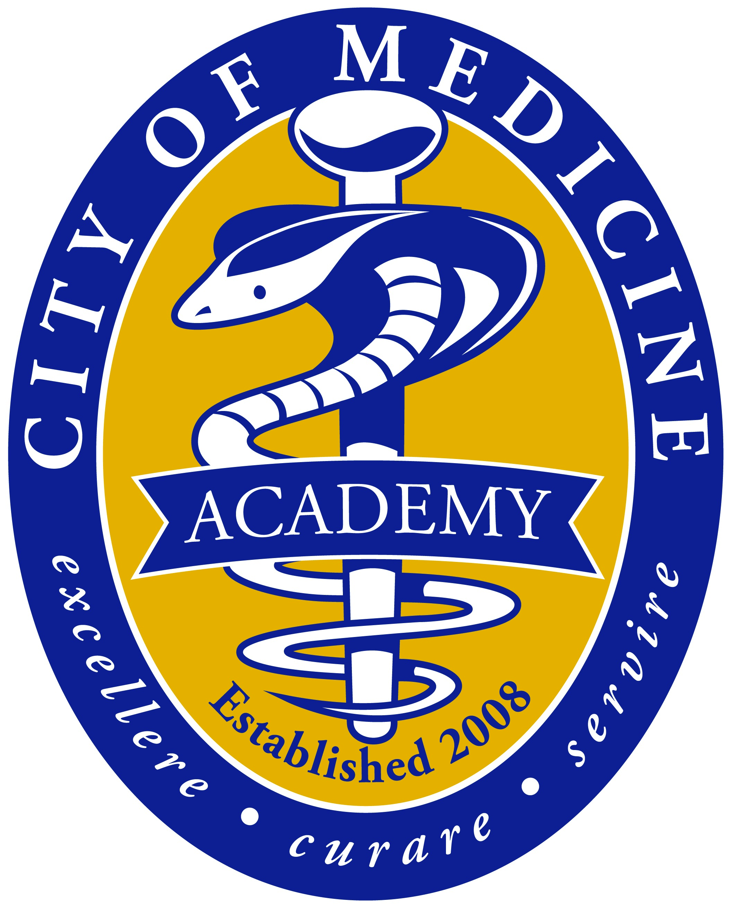
CITY OF MEDICINE ACADEMY
301 Crutchfield Street
Durham, North Carolina 27704
919-560-2001
www.cma.dpsnc.net

August 22, 2019

Dear Parent/Guardian:

This letter is to acknowledge that your child is taking classes at Durham Technical Community College during the 2019-2020 school year. It is my sincere hope that they have had a successful start of the school year and are beginning to settle down in their college courses.

Please remember that your child will not be allowed on CMA campus unless they are attending a high school class. Although some students may not have DTCC classes on Fridays, the bus will transport students to DTCC campus. On days when students do not have a DTCC class, it is recommended that they still go to campus. This is a time that students to study at the library, meet with a study group, or visit their professors with class questions. If students have transportation to CMA, they can study at home until it is time for their 3rd period class.

Transportation to DTCC is only provided on days where both CMA and DTCC are in session. If CMA is closed and DTCC classes are being held, it is the responsibility of the students to provide their own transportation to DTCC classes. On early release days, transportation, will be provided to DTCC, but not back to CMA, please make arrangements for your child to get back to CMA if they need to catch the bus home. Students are expected to be in class any time DTCC classes are being held, this includes, but is not limited to teacher workdays, inclement weather days, and breaks/holidays.

Also, remember that since classes have already started they are not be allowed to withdraw from any classes. Students must also demonstrate satisfactory academic progress by maintaining a 2.0 GPA at DTCC. At the end of each semester, grades will be reviewed to determine continuation in the program.

By signing the attached statement, you are verifying your understanding of the transportation and academic requirements of DTCC students as stated in this letter and giving permission for your child to take the bus from CMA to DTCC daily. Please return the attached form to CMA by September 6, 2019.

Please contact the college liaison at 919-560-5201, extension 17112 or the CDC at extension 17611. If you have any questions. Thank you for your cooperation.

Sincerely,

L. Jackie Tobias, Ed.D., Principal
City of Medicine Academy

By signing below, I am verifying that I understand both the transportation and academic requirements of DTCC students in this letter and am giving permission for my child to take the bus from CMA to DTCC daily. My child will not be on the CMA campus unless he/she is taking a class during the current class period.

PRINT PARENT/GUARDIAN NAME: __________________________________________________

____________________________________________ __________________
PARENT/GUARDIAN SIGNATURE DATE

By signing below, I am verifying that I understand both the transportation and academic agreement of DTCC students in this letter and am giving permission for my child to take the bus from CMA to DTCC daily. I will not be on the CMA campus unless I am taking a class during the current class period.

PRINT STUDENT NAME: __________________________________________________

____________________________________________ __________________
STUDENT SIGNATURE DATE

NOTE: Please return this form to, the DTCC Liaison by September 6, 2019.

